EXPERIMENT 11

**Database.java**

class Database{

private static Database dbobject;

private Database(){

}

public static Database getInstance(){

if(dbobject == null){

dbobject = new Database();

}

return dbobject;

}

public void getConnection(){

System.out.println("Database Connected Successfully");

}

};

**SingletonPatternDemo.java**

class Main{

public static void main(String args[]){

Database db;

db = Database.getInstance();

db.getConnection();

}

}

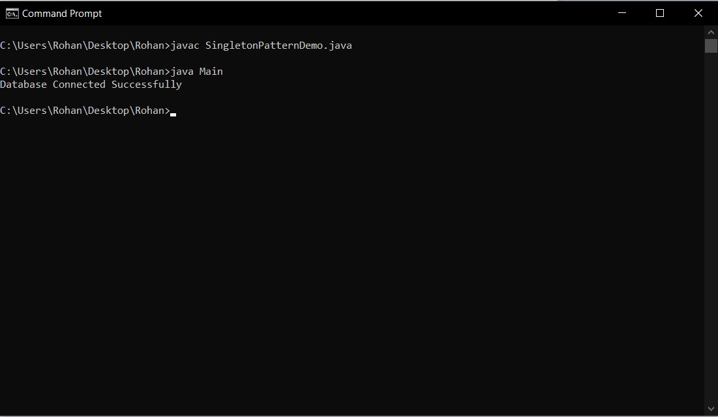**OUTPUT**